HighLevel Project Architecture

Microservice Architecture
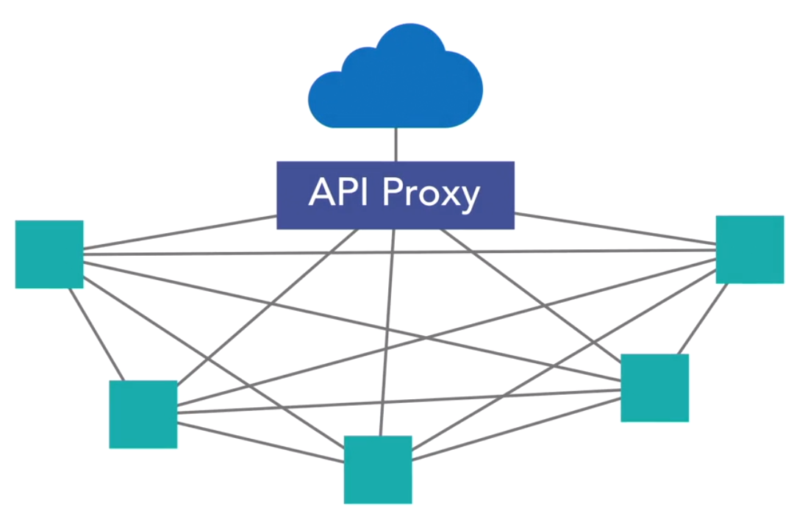

Microservices
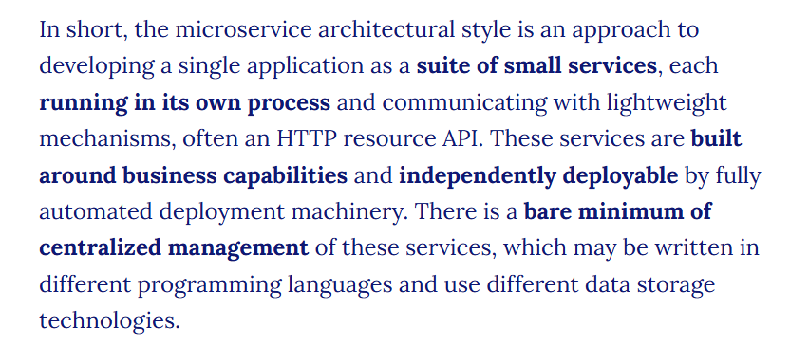
Martin Fowler


- Componentization via Services
- Organized around Business Capabilities
- Smart endpoints and dumb pipes
- Design for failure
- Decentralized Data Management
- Infrastructure Automation
- Decentralized Governance
- Products not Projects
- Evolutionary Design
https://martinfowler.com/microservices/
https://martinfowler.com/articles/microservices.html

9 Key attributes of Microservices as outlines in Martin Fowler's article:

Componentization via services
  - Microservices are structured as independent components or services, each responsible for a specific business function. This modular approach enables flexibility, scalability, and ease of maintenance, as each service can be developed, deployed, and scaled independently.
  - Try as much as possible to make your component as “services”.
  - The modularity of your system should be done using out of process components, also known as services, rather than in process components implemented as libraries.
  - The ease of deployment & maintenance of a system where its components are out of process services is very valuable.

Organized around business capabilities
  - Each microservice is built to handle a specific business function or domain.
  - All closely related business functionalities are grouped together into a single microservice.
  - Instead of dividing teams or code based on technology layers (e.g., frontend team, backend team), microservices are designed and owned based on business features.

Organize services based on the domain. Not on size.

- It isn't much about the size of the service. But it's about the operation of the services which really matters.
- The size of a microservice isn’t fixed or strictly defined. It’s not about how small it is, but about being manageable by a small team (like a "Two-Pizza Team").
- Even though service sizes may vary, they’re all still considered microservices for now.

3. Smart Endpoints and Dumb Pipes:
  - Logic stays inside services, and communication is kept simple.
  - Microservices communicate via lightweight protocols, such as HTTP or messaging queues, with minimal reliance on complex middleware. This design philosophy emphasizes self-contained services that are easy to understand, test, and evolve.
  - Traditional systems (like ESBs) put a lot of logic into the communication layer, making it complex.

How do the services communicate?
  - All communication between individual services in a microservices architecture is over HTTP using REST-based services(in most scenarios).
  - Allows for the use of any coding language or framework that supports RESTful services.
  - 
  - Teams can develop microservices in any technology, however, cross-communication should always be REST over HTTP. So they all communicate in a common way. Despite being developed in any manner. Teams work faster, as they are in the technology they are good at.
  - In Pure Microservices, any service can talk to any other microservice.
    - Hierarchical Service architecture
      - Here you define rules about which service types can or cannot consume other service types.
  - Protocol-Aware Heterogeneous Interoperability.
    - Services are bound to a protocol(HTTP) & execute communication over that protocol in a way that works in a mixed, or heterogeneous, environment.
    - 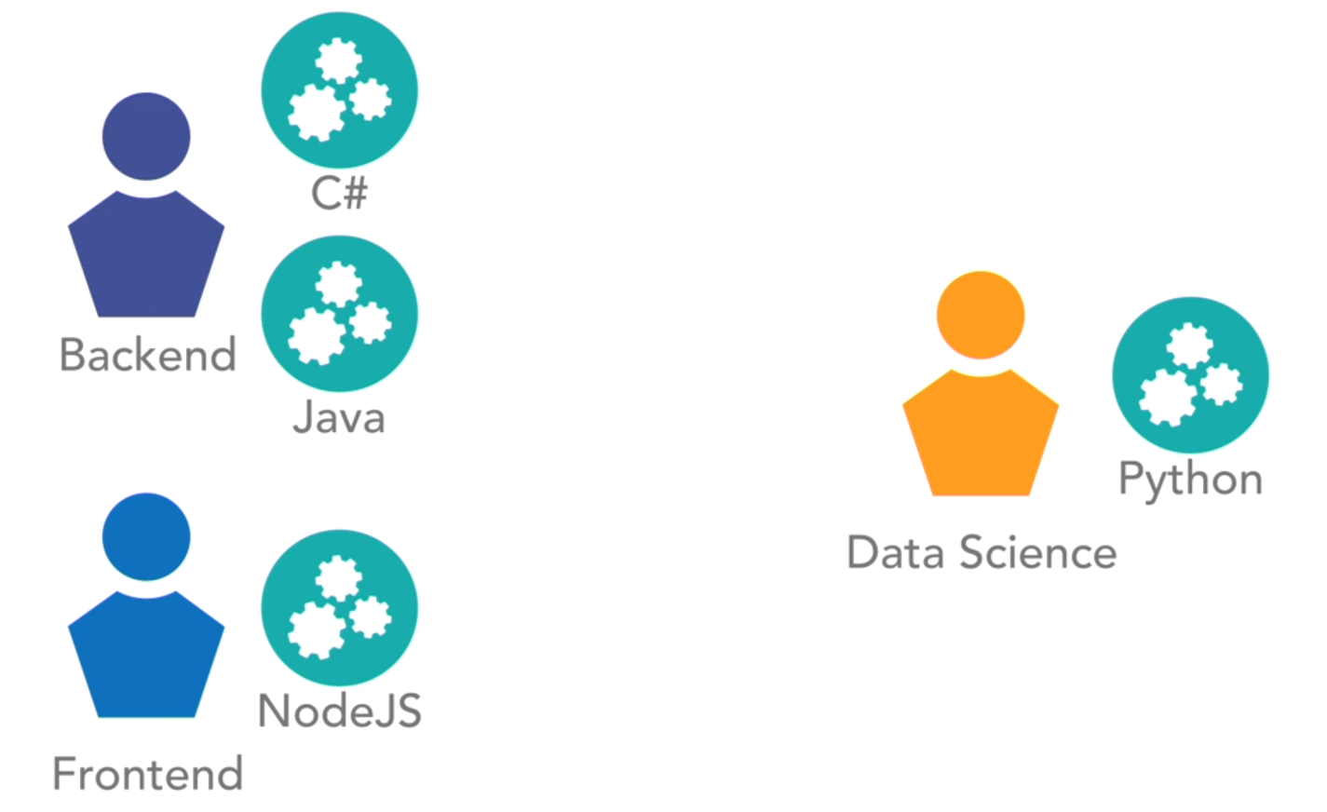

4. Design for Failure:
  - Microservices must be designed to tolerate failure — any service might be unavailable at any time.
  - Tools like circuit breakers, timeouts, and bulkheads are critical for resilience and fault tolerance.
  - Real-time monitoring (both technical and business metrics) is essential to detect and react to issues quickly.
  - Unlike monoliths, distributed microservices require robust observability (dashboards, logs, alerts) due to complex and emergent behaviors.

5. Decentralized data management
  - Each microservice has its own database or data store, allowing teams to choose the most suitable solution for their service's requirements.
  - This decentralized approach minimizes dependencies and supports autonomy, enabling teams to innovate and iterate independently.
  - Using a separate database for each service
  - It makes the service more autonomous & less dependent on other external mechanisms
  - 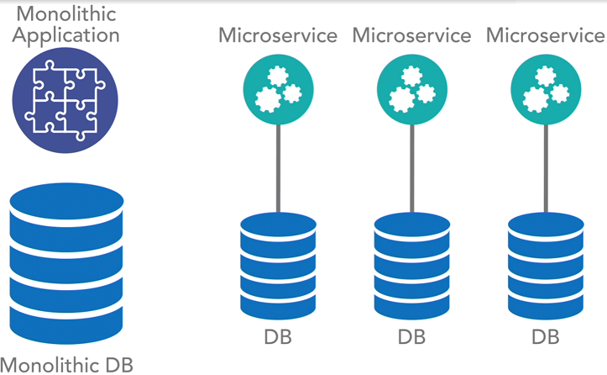
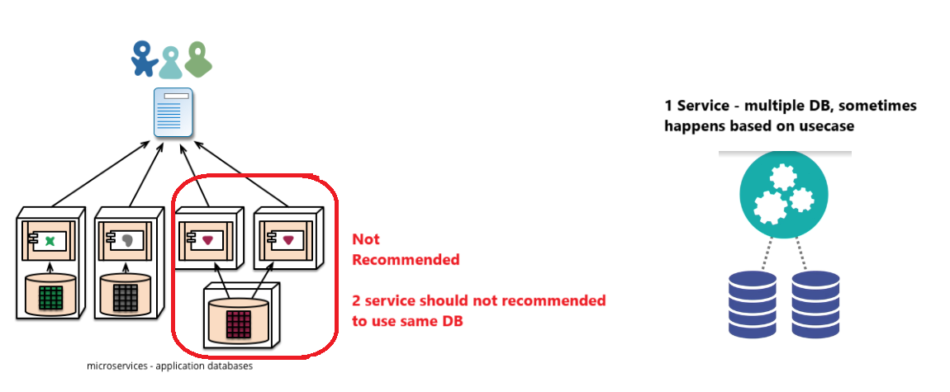

6. Infrastructure automation
  - Microservices rely on automation for deployment, scaling, monitoring, and recovery, enabling rapid and reliable delivery of software at scale. Continuous integration/continuous deployment (CI/CD) pipelines, containerization, and orchestration tools streamline operations and enhance efficiency.
  - Without this automation, would result in a system slow to test & deploy. Clients would get doubts about the effectiveness of it all.

Distribution & Scale:
- Communication patterns lead to a truly distributed model. Distribution beyond a single data center is not a requirement for microservices architecture, it's definitely one of the benefits of this model.
  - With distribution, you can deploy assets across the globe, & expand.
- Supports highly scalable systems.
  - Each application is independent of any other application.
  - As such when individual service comes under load, it can be individually scaled.
  - AWS infra diagram

7. Decentralized governance
  - Decision-making authority and control are distributed across autonomous teams, empowering them to make decisions independently within the boundaries of their respective services. This decentralized approach fosters agility, innovation, and accountability, enabling teams to respond effectively to local requirements and business needs.
  - It lets the teams use the technology best- suited for the services needs.
  - No need of Service handling documents with slow & incompatible relational database
  - No more must we use slow & legacy technology, when what we really need is a light & fast one.
  - Team, can use the best tool for the task. And makes team satisfied, and as a results, the other services and the end users too.

8. Products, Not Projects:
  - Microservices are treated as long-term products with ongoing ownership and responsibility. This approach encourages teams to prioritize quality, reliability, and maintainability, fostering a culture of continuous improvement and customer-centricity.
  - Traditional development follows a project model: build software, deliver it, and hand it over to maintenance.
  - Microservices emphasize a product mindset: the same team builds and maintains the software throughout its lifecycle.
  - The focus is on ongoing improvement of business capabilities, with developers staying engaged with production and user feedback.

9. Evolutionary Design:
  - Microservices prioritize evolutionary design and incremental improvement over upfront planning and monolithic architectures. Services evolve iteratively based on feedback, changing requirements, and emerging business needs, enabling organizations to adapt quickly to market dynamics.

============================
Another practice - The API layer
- The API layer is a common component of a microservices architecture.
  - 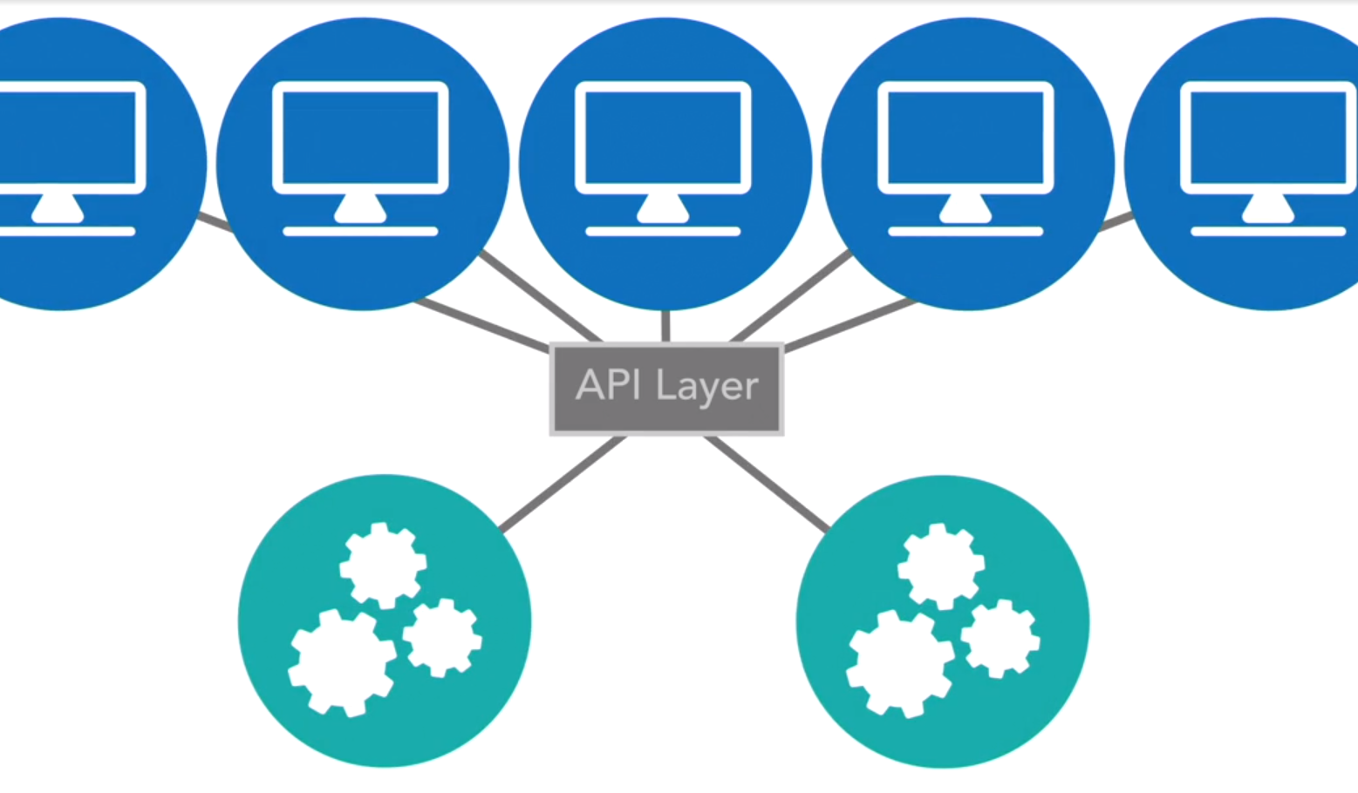
  - API layer should not transform or execute logic.
  - In a pure microservices architecture, an API layer is nothing more than an aggregated proxy of all of your service offerings.
  - The API layer is used, to shield the outside world or your clients from knowing the structure, organization, or even what exact service is exposing a specific operation.
  - The API layer provides a standardized proxy interface that will expose whatever service endpoints & API operations we configure it to expose.
  - The API layer is a pure proxy, with no transformation.
- Concerns
  - Every service invocation in a microservices architecture is over a remote network call. As such, there is connection setup, tear down, and wire latency on every single call. Since is less for 1 call, but as many hops come in place, this adds much more time. GridLock.
    - 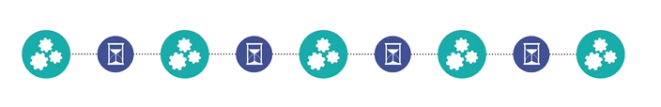
    - When traffic increases & services come under more load, the risk of latency in response time increases.
    - At a certain point, this latency can lead to gridlock of the system as a whole. When calls are waiting for responses, delays can become unbearable, when this occurs, there could be a catastrophic failure.
  - Circular calls:
    - 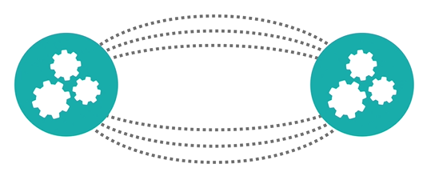
  - The solution could be a circuit breaker. Cut down some of the features. .and continue a defined path.
  - Solution: Strong timeouts, Global distribution of all services offered, scaling of individual services under load & leveraging patterns like circuit breakers will help to solve problems when they do occur.

